DOOR OF HOPE [NPO]: BUSINESS PROPOSAL

THE INDEPENDENT INSTITUTE OF EDUCATION (IIE)

MODULE NAME: WEB DEVELOPMENT
MODULE CODE: WEDE5020
PRESENTED BY: MASHUDU MUNYAI
STUDENT NUMBER: ST10511542
GROUP 2

Table of Contents
ORGANISATION OVERVIEW 3
WEBSITE GOALS AND OBJECTIVES 3
KEY PERFORMANCE INDICATORS 3
CURRENT WEBSITE ANALYSIS 4
PROPOSED WEBSITE FEATURES AND FUNCTIONALITY 4
DESIGN AND USER EXPERIENCE 5
TECHNICAL REQUIREMENTS 5
TIMELINES AND MILESTONES 6
Budget 6
REFERENCING 7

ORGANISATION OVERVIEW
- Name: Door of Hope
- History: In 1999, a stainless-steel Baby Saver Box was built into the wall of a church in Johannesburg to address the rapid increase in child abandonment. This is how the Door of Hope was established. (Door of Hope, n.d.)
The organisation gives mothers a safe and anonymous solution other than abandonment, which has helped save many children over the years. (Door of Hope, n.d.)
- Vision and Mission statement:
Vision statement - To restore hope and reflect Christ’s love by caring for abandoned babies and helping them find safe and loving families. (Door of Hope, n.d.)
Mission statement – To receive abandoned babies and children in need of care and protection, giving them a chance at a better future. (Door of Hope, n.d.)
- Target audience: Neglected babies and children, because that is the organisation’s primary focus. (Door of Hope, n.d.)
Mothers who are considering neglecting their children, families who are looking into adoption, donors/investors, and supporters of the organisation. (Door of Hope, n.d.)

WEBSITE GOALS AND OBJECTIVES
- Increase website traffic
- Raise awareness
- Raise money
- Attract volunteers
- Help families looking into adoption
- Build a supportive and honest community

KEY PERFORMANCE INDICATORS
- WEBSITE TRAFFIC
- measures the number of website visits per month.
- AVERAGE SESSION DURATION
- measures how many people engage with their content
- DONATION RATE
- measures the total percentage of how many people complete a donation
- VOLUNTEER SIGN-UPS
measures how many people register to volunteer
- CONTACT FOR ENQUIRIES
- calculates how many people reached out to ask questions or enquire about anything concerning the NPO

CURRENT WEBSITE ANALYSIS

STRENGTHS
- CLEAR PURPOSE AND MISSION
- the website is very clear in explaining that their main focus is to help neglected kids, which ultimately leads to people quickly understanding their goals.
- EMOTIONAL/PHYSICAL IMPACT
- because it uses real-life testimonies/stories and images, it really helps the user create an emotional bond and pushes people to take part in the organisation’s cause.
- DONATION/FUNDING FOCUSED
- the existing website already makes it easy for one to complete a donation.
- COMPLETE INFORMATION
- it is not hard to find information concerning the NPO.
- EASY WEB-NAVIGATION
- it’s easy to find your way around the webpages.

WEAKNESSES & IMPROVEMENT
- Outdated website design | Modernise it by updating it with a clean and visually appealing layout
- Less interactive features | Features like live chats, donation programs, or interactive stories can drastically improve user engagement
- Lack of good SEO | Using better keyboards, headings, and descriptions will help the website appear at the top of Google search results, potentially attracting more visitors. (OpenAI, 2026)
- Lack of strong call-to-actions | Strengthening it using phrases like “DONATE NOW!”, “VOLUNTEER TODAY!”, “CONTACT US” should be visible and strategically placed to intrigue user participation

PROPOSED WEBSITE FEATURES AND FUNCTIONALITY
- Homepage: it gives the visitors an overview of the organisation, which includes key sections like introduction and quick links to important pages
- About Us: information about the NPO
- Donate page: allows visitors of the website to complete donations
- Volunteer page: allows visitors to register for volunteering
- Testimonies/Update page: to show users of the page and prospective supporters the progress of the organisation.

DESIGN AND USER EXPERIENCE
Colour Palette
- Blue – for trust and safety, all while being professional
- Black – professionalism (used as font colour)
- White – for purity and peace, which also keeps the website clean
- Pastel Grey – symbol for hope and warmth (background colour)
Typography
- Headings: Ariel/Helvetica/Poppins
- Body: Open Sans/Roboto
Hierarchy

Layout and Design [overall design approach]
The website is going to have a neat, modern, and user-focused style with a clear layout, consistent look, and a design that looks good on every type of device. It will have clear navigation, good use of pictures and space, and Strong calls-to-action to make the user experience better and help the organisation achieve its goals.
User Experience Considerations
- easy navigation and website layout
- fast loading speed
- accommodate all types of devices
- clear call-to-action
Wireframe
HOME PAGE
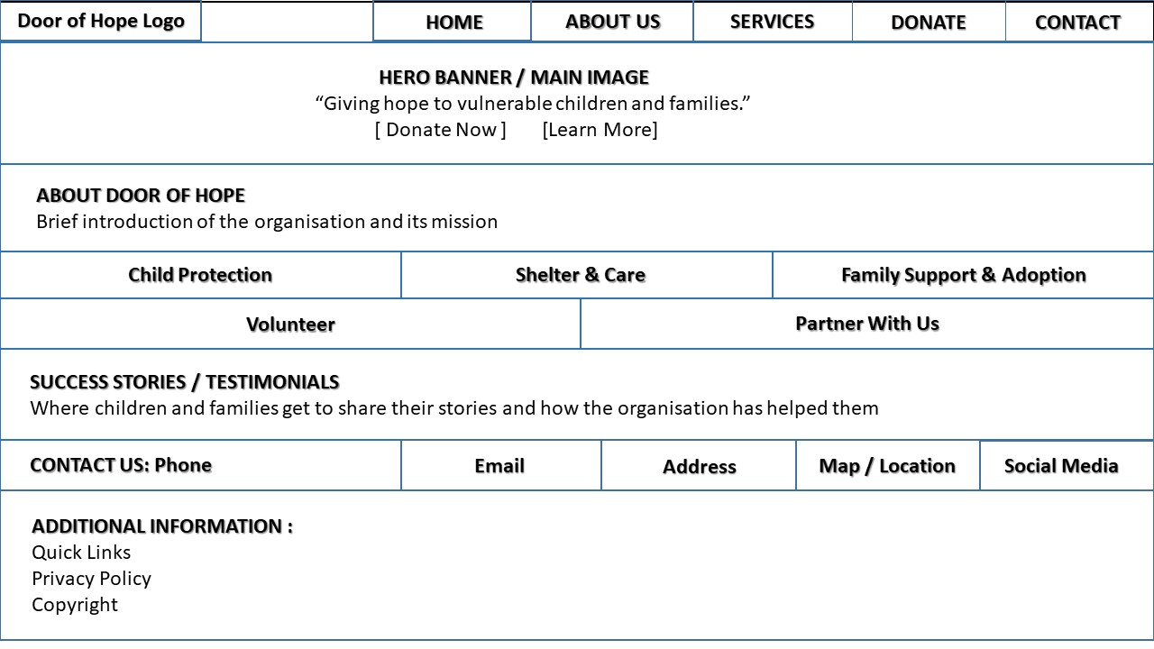

ABOUT US PAGE SERVICES
LOGO

FOOTER
IMAGE OF THE ORGANISATION
LOGO

PICTURE OF OUR SERVICES/THE CHILDREN CENTRE

PICTURE OF ANOTHER SERVICE

FOOTER
FOOTER

DONATE PAGE / PARNERSHIP VOLUNTEER
PICTURE OF HANDSHAKE OR DONATE

SIGN UP FORM
PICTURE OF PEOPLE VOLUNTEERING AT CHILDREN HOMES

CONTACT PAGE

MAP/LOCATION

TECHNICAL REQUIREMENTS
- DOMAIN NAME: www.doorofhope.org - HOSTING: SHARED HOSTING
- HTML
- JavaScript
- CSS

TIMELINES AND MILESTONES
- Week 1-2: Research and planning (25 March-5 April)
- researching info about the organisation
- Week 3: Design phase (06-10 April)
- create wireframe, colour scheme and font. plan website features
- Week 4: Testing and improvement (11-15 April)
- building a website using HTML
- create main pages, add images, content, and styling.
- Week 5: Review and submission (16-20 April)
- go through every detail and consult for a review, then submit

Budget
- Development Cost(once off) | R6 000
- Domain name(annually) | R120
- Hosting (monthly) | R150 p/m
- Maintenance (monthly) | R300 - R450

First year total | R11 520
Ongoing yearly cost | R5 250 (excl. developing cost)

REFERENCING
Door of Hope. n.d. About Us. Available at: https://doorofhope .co.za/about-us/(Accessed on: 31 March 2026)
Hostigo. n.d. How much does a website cost in South Africa (2026 guide).Available at: https://hostigo.co.za/how-much-does-website-cost-in-South-Africa-2026-guide/(Accessed on: 4 Aril 2026)
OpenAI,2026. ChatGPT assistance in developing a website’s KPIs for an NPO project. Available at: https://chat.openai.com.(Accessed: 31 March 2026)

